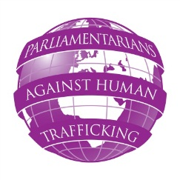
SEMINAR ON PREVENTION OF HUMAN TRAFFICKING

THURSDAY 24 NOVEMBER 2011
HOUSES OF PARLIAMENT, LONDON

Monday 26 September 2011
Dear colleague,

The first seminar will be entitled ‘prevention of human trafficking’. It will be held in the Houses of Parliament in London Thursday 24 November 2011.

The costs of travel to the seminar and one night of accommodation at the seminar hotel will be covered by the European Commission and the Tudor Trust, who are jointly funding this EU wide project.

Given your interest and existing commitment to combating human trafficking, you may be interested to know that the seminar will provide a forum for parliamentarians, NGOs, law enforcement agencies and representatives from the business community to focus on two key points:

- How are EU member states complying with the EU directive on preventing and combating trafficking in human beings?

- Do international sports events increase the risk of trafficking in human beings?

I would very much like you to attend. There will be parliamentarians from the UK, Germany, Austria, Denmark, Italy, Romania, Portugal and Poland. Please email Emma Makey, Project Assistant at e.makey@ecpat.org.uk no later than Monday 24 October 2011.

Peter Bone MP

Joint Chairman
All Party Parliamentary Group on Human Trafficking

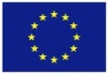

With the financial support from the Prevention of and Fight against Crime Programme of the European Union,
European Commission – Directorate-General Home Affairs

and the Tudor Trust

