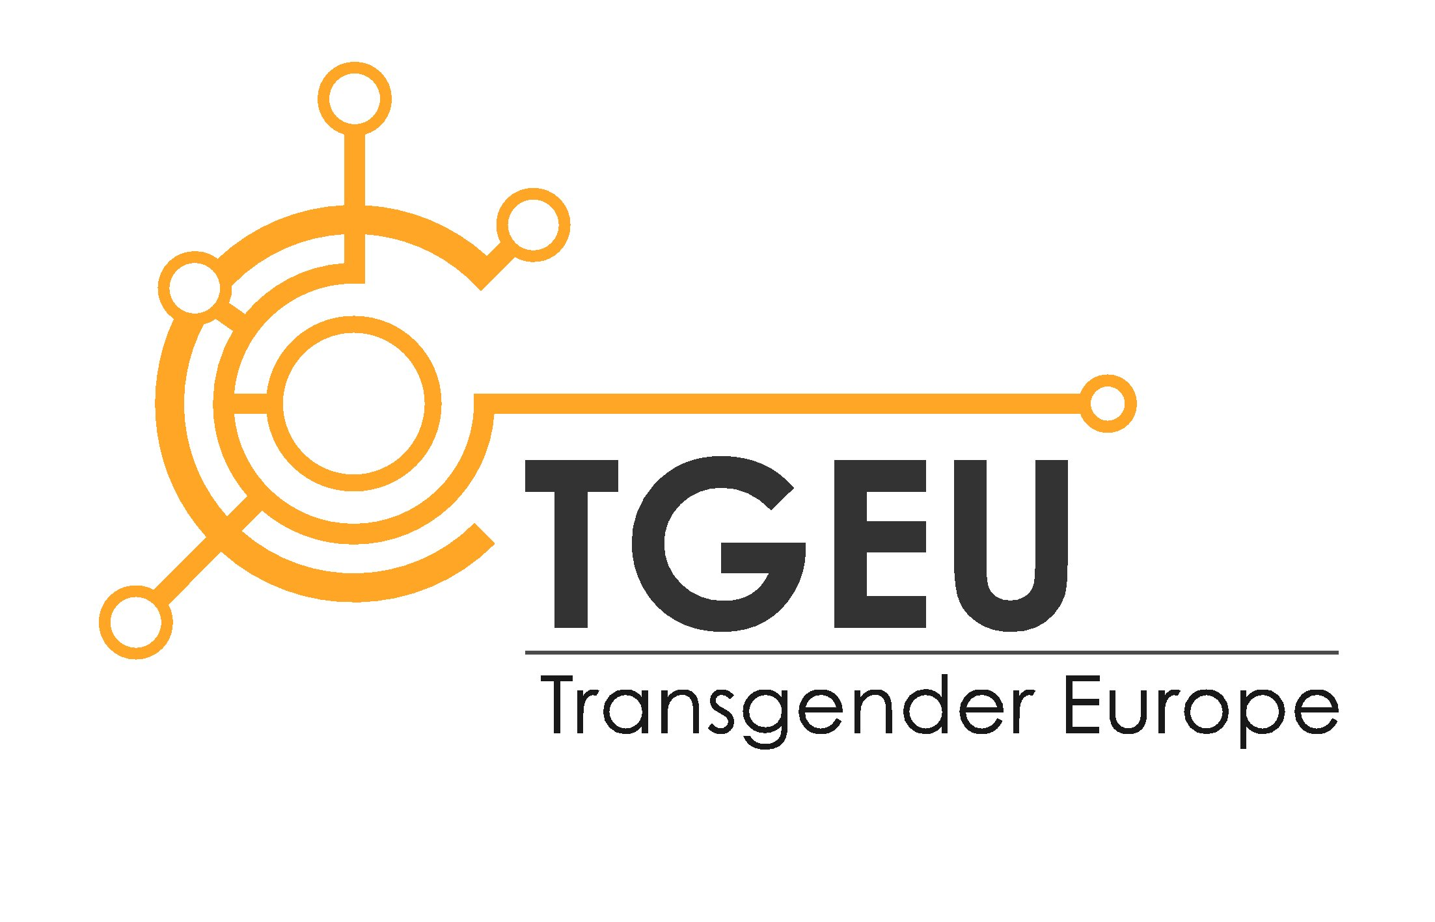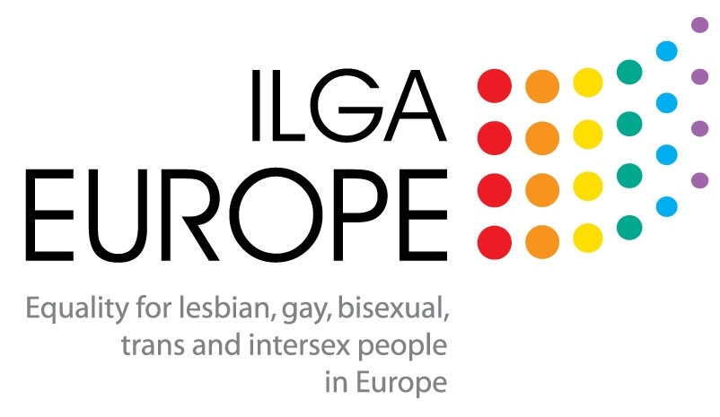

ILGA-Europe, Transgender Europe and OII-Europe’s comments to the Law Proposal Nr. 75/XIII 2nd which establishes the right to self-determination of gender identity and gender expression and the right to the protection of sex characteristics of each person
2018-01-31
- Comments on the explanatory statement

  - On the terminology used:
The terminology used in the whole document is sometimes incorrect and may confuse readers, in particular, those who are not familiar with issues faced by trans and intersex persons. We therefore recommend being extremely careful not to confuse terms such as ‘trans’ and ‘intersex’ or ‘gender identity’ and ‘sex characteristics’ or ‘sex’ and ‘gender’.
Please find below correct definitions to use for those terms:
Gender expression: Refers to people's manifestation of their gender identity to others, by for instance, dress, speech and mannerisms. People’s gender expression may or may not match their gender identity/identities, or the gender they were assigned at birth.
Gender identity: Refers to each person’s deeply felt internal and individual experience of gender, which may or may not correspond with the sex assigned at birth, including the personal sense of the body (which may involve, if freely chosen, modification of bodily appearance or function by medical, surgical or other means) and other expressions of gender, including dress, speech and mannerisms. Some people's gender identity falls outside the gender binary, and related norms
Gender reassignment: Refers to the process through which people re-define the gender in which they live in order to better express their gender identity. This process may, but does not have to, involve medical assistance including hormone therapies and any surgical procedures that trans people undergo to align their body with their gender.
Legal gender recognition: A process whereby a trans person’s gender is recognised in law, or the achievement of the process.
Intersex: A term that relates to a range of physical traits or variations that lie between stereotypical ideals of male and female. Intersex people are born with physical, hormonal or genetic features that are neither wholly female nor wholly male; or a combination of female and male; or neither female nor male. Many forms of intersex exist; it is a spectrum or umbrella term, rather than a single category. That is why intersex activists frequently prefer to use the term sex characteristics (for example, when talking about grounds that can be protected against discrimination). There is not one static state called 'intersex status', so using the term sex characteristics reflects the fact that being intersex is a bodily experience and only one part of a person's identity.
“Intersexual” (referred to in article 2.g) is not the correct term and should not be used as the issue here is about sex characteristics and not about sexuality or sexual orientation.
  - On the binary model:
We welcome the reminders on the context in which that draft law is put forward: “universality of human rights” and “self-determination”. In that framework, we think it is important not to refer to “sex and gender binary marker considered natural”, and to expressions such as “these” people. The definition given in the draft law of the word “sex” is also problematic when it refers to the distinction of “men and women”. These formulations can be counter-productive and reinforce a binary model that would be seen as the norm, broken by a minority of persons that the majority would have no other choice than tolerate.
  - On the deferral of non-consensual medical treatments:
In the absence of an express wish, (with free, full and informed consent of the intersex individual) all surgeries, hormone treatments and other invasive medical procedures that are not strictly medically necessary must be banned.
Then, the criteria to decide when not strictly medically necessary treatments do not have to be deferred anymore should not be based on the moment when the gender identity of the child or the person is manifested. Indeed, young people should be allowed to explore their gender identity, and in many cases, this gender identity evolves or may not be strictly binary.
  - On legal gender recognition of intersex people
We very much welcome the proposed option consisting of providing intersex persons with a possibility of getting their gender marker corrected through “simple administrative proceedings”. We also appreciate the intention not to replicate mistakes done in other contexts consisting in imposing a third gender option to anyone.
- On Chapter I, article 7: modifications of body/sex characteristics of minors
The article seems to imply that even in a situation where the health of the person would be at risk, medical treatments should not be performed if the person cannot consent. We consider that medical treatments should take place in life threatening situations and even if the person cannot consent. However, it is critical to make clear that those real life threatening situations are extremely specific and are not common. In all situations that do not cause an immediate threat to the life of the intersex person, all interventions and treatments must therefore be deferred until the person to be treated can provide informed consent. Following the Maltese example “only in exceptional circumstances treatment may be effected once agreement is reached between [an] Interdisciplinary Team and the persons exercising parental authority or tutor of the minor who is still unable to provide consent: Provided that medical intervention which is driven by social factors without the consent of the minor, will be in violation of this Act.”
The Interdisciplinary Team should be appointed by the government and consist in equal parts of human rights defenders with a special knowledge about intersex issues, independent psychologists and medical professionals. The decision process should be documented comprehensively in order to allow the intersex person to retrace it later in life.
In order to ensure intersex people’s access to justice, the retention period for medical records should be such that it allows intersex people to access their records as capable adults. The statutes of limitation should match with the retention period.
We would also like to reiterate that the criteria to be taken into account here is not “the moment in which the person’s gender identity is manifested” given gender identities can be fluctuant and are often not strictly binary.
- On Chapter II: Legal recognition of gender identity

  - On Article 8: procedure

    - Art. 8-1: “Procedure for a sex change” should be replaced by “procedure for legal gender recognition”.
    - Art. 8-2: We welcome the measures proposed to ensure the confidentiality of the legal gender recognition procedure, but suggest introducing into the law explicit mechanisms of enforcement.
    - Art. 8-3: the legal gender recognition procedure proposed through this draft law is based on self-determination. We believe that if a person applies again for legal gender recognition it should also be based on self-determination: where a person’s gender identity would change after a legal gender recognition procedure has taken place, they should be able to get their gender legally recognised through a procedure as simple as the previous one.
    - Art. 8-4: We welcome the fact that the recognition of foreign decisions is explicitly regulated by this article. However, we are also critical that access to the procedure for foreign residents, including refugees, is not regulated in this draft law.
    - Additional considerations: In reference to PACE resolution 2048(2015) Article 6.2.4. we suggest to introduce the explicit possibility for a third gender marker on the basis of self-declaration, for those who seek it, such as “x”, a different “marker”, leaving it blank or opting for removal of a gender marker altogether.

  - On article 9-2: legitimacy
The procedure of legal gender recognition should be available to all without any age limit. There is no reason why children should have their fundamental rights less protected than adults. Changing one’s name and gender as a child cannot be harmful nor have irreversible consequences. On the contrary, allowing children to legally change their gender facilitates their social transition in school, which is a prerequisite for their well-being. Children’s best interests should be the core principle in the decision-making on their legal gender recognition.
  - On article 11-3: medical treatments
We welcome the express mentioning of the prohibition of requesting evidence of “medical procedures, sex reassignment surgery, sterilization or hormonal therapy, (…) psychological or psychiatric treatments” as basis for a decision on the legal gender recognition procedure of a person.
- On Chapter III: Measures of protection

  - On article 13: health

    - Art. 13-3: We welcome this article which would contribute to ensure the respect of intersex people’s right to full information and access to their own medical records and history.
    - Art. 13-4:
Article 13.2 (Health) inscribes a leading role to psychiatry in access to gender confirming treatment. This is against the spirit of this law, which is based on self-determination. We suggest to delete Article 13.2) and extend article 12.4) by the development of a healthcare protocol that is based on the informed consent model, ensuring that those seeking gender affirming treatment can have access to it without having to be subjected to mandatory psychiatry assessments.

  - On article 14
The measures proposed in the area of education are very relevant and important. We reiterate however that the ability of minors to get their name changed and their gender recognised would greatly improve their schooling life – and therefore their overall well-being. Similar provisions should be adopted to enable the change of work-related certificates and documents, whether issued by state or non-state actors.
Persons of contact:
Richard Koehler, Senior Policy Officer; Deputy Executive Director, Transgender Europe (TGEU), richard@tgeu.org
Dan Christian Ghattas, Executive Board, Co-Chair, Organisation Intersex International Europe (OII Europe), dan@oiieurope.org
Sophie Aujean, Senior Policy and Programmes Officer, European region of the International Lesbian, Gay, Bisexual, Trans and Intersex Association (ILGA-Europe), sophie@ilga-europe.org

